**Games List**

**Description**: Create, edit, or delete details of video games using .NET database

**Features:**

* Homepage displays current time
* Create new games in table
* Delete or edit details of previously saved games

Home Page

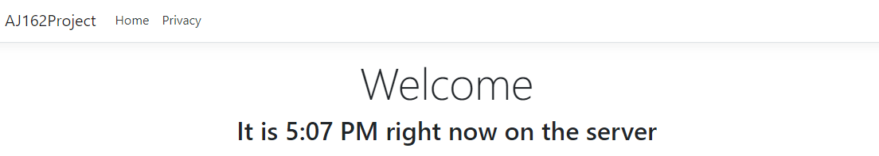

Games Page

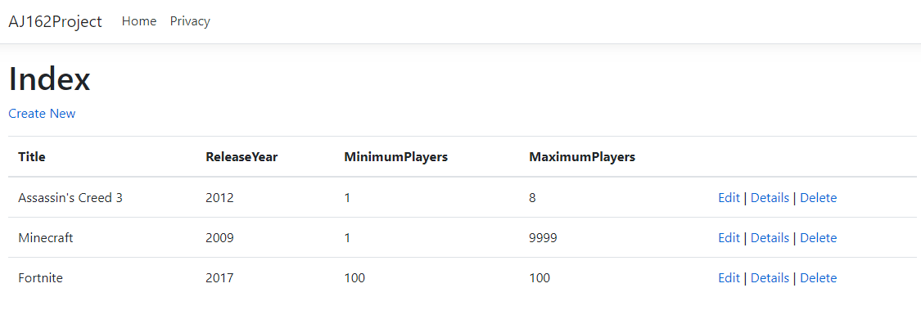

Insert New Game

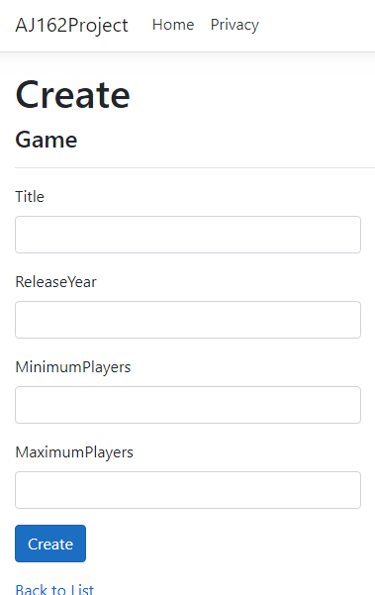

Edit Game

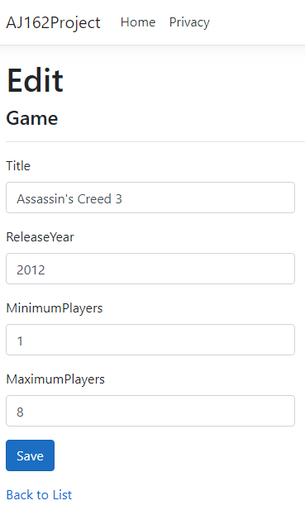

Delete Game

